Dear [Immediate Supervisor],
The Professionals In Human Resources Association (PIHRA) is the largest SHRM affiliate in the United States. PIHRA is well known in Southern California for providing HR professionals with the professional development, networking and tools needed to help make a positive impact on the organizations they serve. I believe a PIHRA membership is critical to help me bring ideas and approaches to our organization and further my professional development. This is particularly important in these times of uncertainty. I request your approval and a budget to become a member.
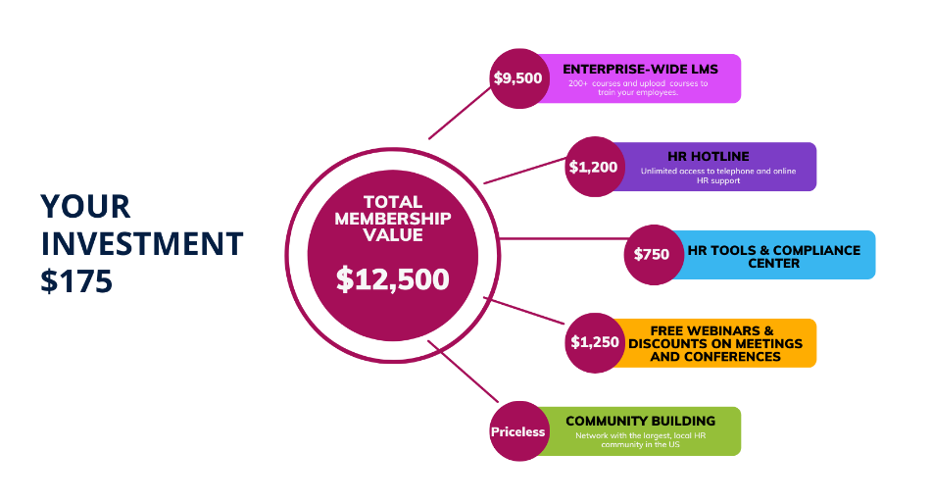
The PIHRA membership is an annual membership that costs $175/year. For $175, you receive $12,500 of value. The graphic illustrates some of the member benefits that I would have. For a full listing of member benefits, feel free to visit the PIHRA Member Benefits page. In addition, a full schedule of learning events is available at pihra.org/calendar.
I plan to use the PIHRA benefits to contribute to the ongoing success of the organization and strengthen my professional development. [List the benefits or webinars/conferences you plan to use/attend. Add the learning objectives and how they will benefit you, your team, and your organization.] ____________________________________________________________________________________________________________________________________________________________________________________________________________________________________________________________
Here are my projected costs for becoming a PIHRA member in the upcoming year.
Membership Fee + Educational Events $ xx.xx

This investment will pay off in more efficient practices, proven solutions, new insights, and ideas. Before my annual membership expires, I will provide a summary of my key takeaways and achieved goals.
I would appreciate your approval of this request. I will work to ensure we get the full value from this investment.
[Your Name]

