YOUR COMPANY LOGO HERE

Dear [Supervisor’s Name],
Professionals In Human Resources Association (PIHRA) is the largest SHRM affiliate in the US. PIHRA is known in Southern California for providing HR professionals with the professional development, networking and resources needed to help make a positive impact on the organizations they serve. I believe a PIHRA membership is critical to help me bring new ideas and approaches to our organization and further my professional development. For this reason, I request your approval and a budget to become a member and participate in PIHRA conferences, chapter meetings and webinars.
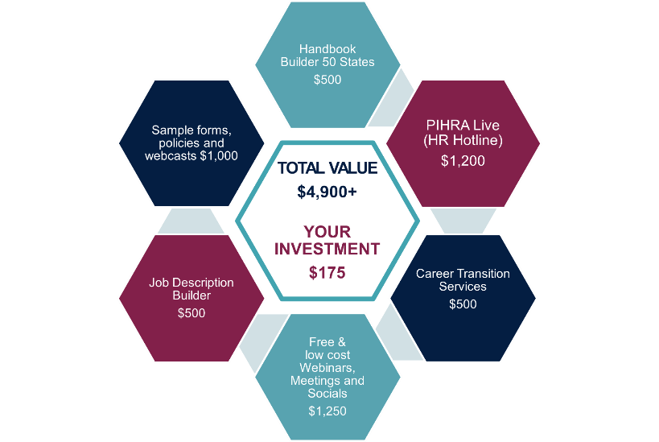
The PIHRA membership is an annual membership that costs $175/year. This is 20% lower than the cost of other HR association memberships. I will receive more than $4,900 of value. The graphic below illustrates some of the member benefits that I will have access to and help me betters support the organization and the HR department.
For a full listing of member benefits, feel free to visit the PIHRA Member Benefits page at pihra.org/benefits. In addition, a full schedule of learning events is available at pihra.org/calendar.
I plan to use the following benefits to contribute to the ongoing success of the organization and strengthen my professional development.
(List the benefits or webinars/conferences you plan to attend as well as your learning outcomes and how they will benefit you, your team and your organization.) ____________________________________________________________________________________________________________________________________________________________________________________________________________________________________________________________
Here are my projected costs associated with the PIHRA membership this year.
Membership Fee + Educational Events $ xx.xx

This investment will pay off in more efficient practices, proven solutions, improved regulatory compliance, new insights and ideas. Before my annual membership expires, I will provide you with a summary of my key takeaways and the results that I achieved.
I would appreciate your approval of this request. I look forward to discussing this with you further.
Sincerely,
[Your Name]

